FOR IMMEDIATE RELEASE | Contact: | Sara J. Arnold  Publisher and Editor  June Road Press | editor@juneroadpress.com  203-247-6488

DEBUT POETRY COLLECTION GARNERS FIVE HONORS
Book from Small Press Recognized by Literary Community

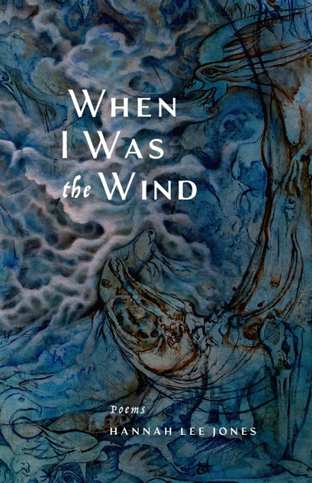
Berwyn, PA (Sept. 7, 2023) — For Hannah Lee Jones, publishing her first book of poetry last October and knowing it was connecting with readers was its own reward. She didn’t expect prizes—let alone five. Since April, When I Was the Wind has won both the Eric Hoffer Book Award in poetry and the First Horizon Award for outstanding debut books, taken top “gold” honors in the Nautilus Book Awards, become an IPPY Awards bronze medalist, and, most recently, been named a Washington State Book Award finalist.

For Jones, 42, who has focused her promotional efforts on deep social media engagement rather than in-person readings and did not pursue a traditional MFA route to publication, these honors have been especially validating.

Calling Jones “a new voice for these times,” the Eric Hoffer Award judges noted that the book has “a fascinating rhythm—bright and flowing, creating its own dance.” The panel praised the work’s spirit of exploration and ability to make readers “take notice of our own fragility and that of the world,” concluding: “With an undercurrent of grit, there is just enough magic here to intrigue all who still want to believe in the best within us all.” Readers have characterized the collection as “urgent and gorgeous,” “deeply renewing,” “exquisitely fierce,” “filled with art and myth,” and “a travel companion through the American West.”

Originally from Tacoma, Jones now divides her time between Port Townsend, Washington, and Silver City, New Mexico, after spending three years as a nomad in the desert Southwest following a divorce, living out of a tiny handmade trailer house around Moab and the Four Corners region. Her book, years in the making, draws on that unusual journey as well as her Korean heritage and path toward healing from childhood trauma. Its layered structure, substantial notes section, and artisan details set it apart from standard poetry collections, and Jones worked closely with her publisher on every element.

When I Was the Wind is the third book published by June Road Press, a one-woman independent publisher in Pennsylvania. The fourth, a book of ecopoetry (There Are Still Woods by Hila Ratzabi), also won gold in the Nautilus Awards this year. The fifth and sixth books, which take on themes of motherhood, immigration, grief, and love, are out this fall.
The Eric Hoffer Award and the IPPY Awards honor books in the independent publishing industry from small and academic presses, and the Nautilus Awards celebrate “books for a better world” that support a mission of social justice, sustainability, spiritual growth, and wellness. The winners are announced in the spring after a rigorous judging process involving members of the literary community, including editors, librarians, agents, authors, and other experienced professionals. The Washington State Book Awards honor books by Washington authors “based on the strength of the publication’s literary merit, lasting importance and overall quality.”
Author Hannah Lee Jones (credit: Hannah Lee Jones)
June Road Press is an independent micropress based outside Philadelphia. Established in 2020, the press currently publishes two poetry collections a year, with an emphasis on women-identified emerging writers, and strives to make finely crafted books that are both timely and timeless. For more information, visit juneroadpress.com or contact Sara Arnold, publisher and editor, at editor@juneroadpress.com.

# # #

